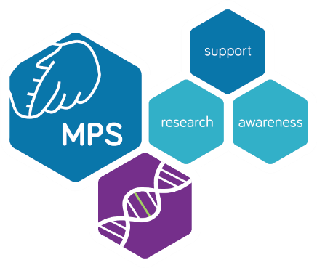

[Organisation’s name/fundraiser’s name] to hold [type of event] for national charity the MPS Society

[Organisation’s name/fundraiser’s name] from [location] will be holding a fundraising event on [date] to help raise vital funds for the MPS Society, a fantastic charity which provides support for children and families affected by one of 25 rare, life-limiting genetic conditions.

The MPS Society has been helping those affected by rare genetic conditions for the past 30 years and is the only charity in the UK which focusses on MPS (Mucopolysaccharide), Fabry and related disorders which can cause a range of progressive and life-limiting disabilities. Every 8 days, a baby born in the UK is diagnosed with MPS or a related disease so this wonderful charity strives to transform lives through specialist knowledge, support, advocacy and research.

[Organisation’s name/fundraiser’s name] would like to invite the local community to come along to join in the fun. [Add more info about the event here, including name, times of event, activities etc].

As a small charity, the MPS Society is entirely reliant on donations and fundraising. Rare diseases can be isolating and lonely so the MPS Society’s Advocacy Team works closely with those affected by providing an active listening service and helpline. They also provide help with accessing disability benefits, housing, home adaptations, education, referrals to social care, signposting, befriending, bereavement and more. They also organise fun events for their members and hold national conferences and expert meetings.

[Organisation’s name/fundraiser’s name] is looking forward to seeing you on [date]. For more information about the MPS Society, please visit www.mpssociety.org.uk or email communications@mpssociety.org.uk

Notes to Editors

- Founded in 1982, the MPS Society is the only UK registered charity supporting children, young people and adults affected by MPS (Mucopolysaccharide), Fabry and related rare diseases.
- These diseases are rare, genetic and life-limiting. They cause a range of problems such as short stature, speech and language difficulties, mobility issues and neurological issues.
- The charity supports approximately 1,500 affected individuals across the UK and wants all affected people to know where to turn for specialist knowledge, support and advice. Each member is paired with a dedicated Support Officer to help them and their family at home, in hospital and in the community. For more info, see https://www.mpssociety.org.uk/advocacy.
- The charity champions new and existing therapies, collaborates on innovative, world-class research and always strives to raise awareness of these conditions. There is no cure for these diseases but with each new advancement in treatment, lives can be lived to the fullest.
- The charity needs to raise over £1 million each year to fund their vital support services.

For press opportunities or more information about the MPS Society, please contact Sophie Dowsett and Helen Crawley by emailing communications@mpssociety.org.uk or calling 0345 389 9901. Thank you.

